PGM-19 Jupiter | 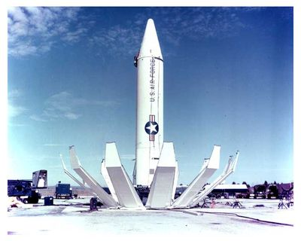
Length: 60 ft (18.3 m)
Diameter: 8 ft 9 in (2.67 m)
Total Fueled Weight: 108,804 lb (49,353 kg)
Range: 1,500 mi (2,410 km)
Warhead: 1.45 Mt Thermonuclear W-49 - 1,650 lb (750 kg)

data sheet R-14
country | USSR
other names | SS-5 Skean, 8K65, Usowaja
class | MRBM medium range
payload | 1,300-2,155 kg
warhead | 1 nuclear 1 MT or 2-2.3 MT
length | 20.60 m
diameter | 2.40 m
takeoff weight | 87,000 kg
range | 4500 km
service | 1961-1984

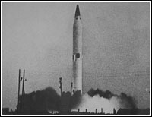

data sheet R-12
country | USSR
other names | SS-4 Sandal, Dwina, 8K63
class | MRBM medium range
payload | 1,630 kg
warhead | nuclear 1-1,3 Mt or 2-2,3 Mt
length | 18.40 m
diameter | 1.65 m
takeoff weight | 41,700 kg
range | 2000 km
service | 1959-1987

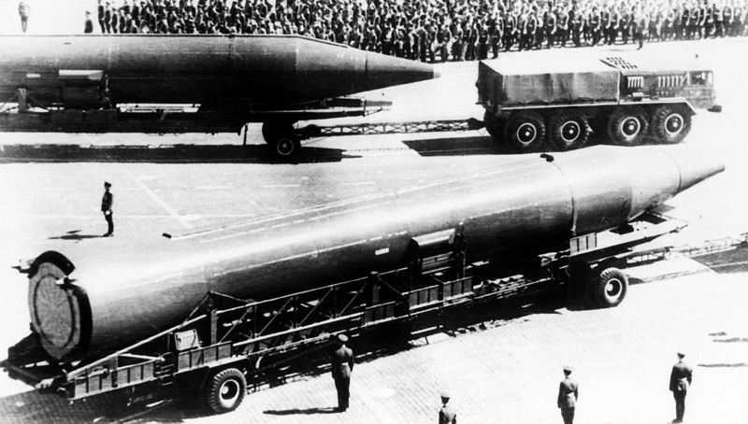

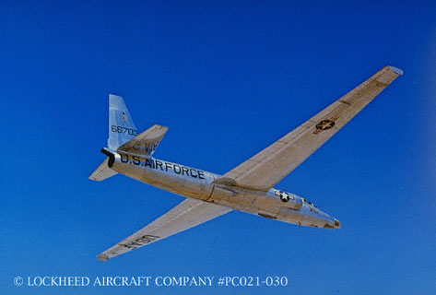 Lockheed U-2 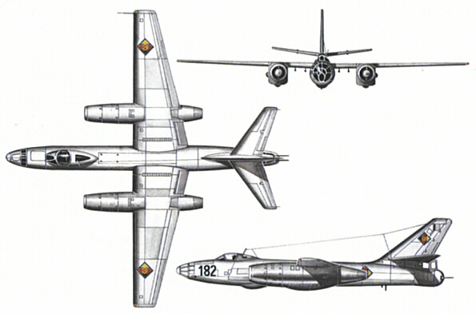 Iljuschin IL-28

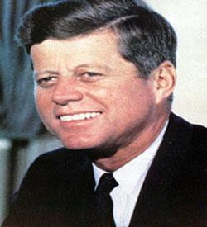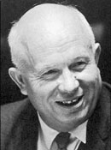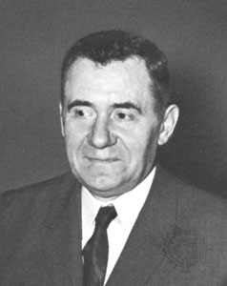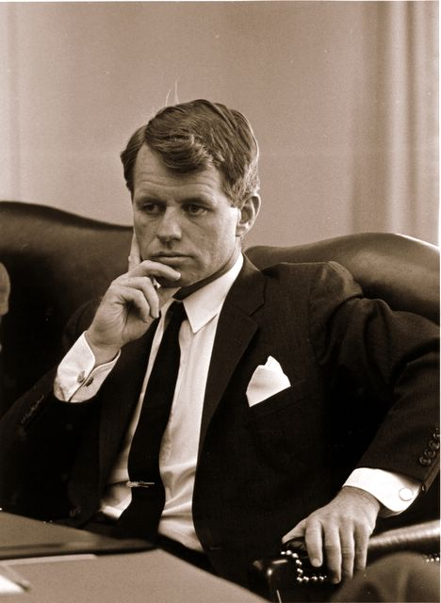
JFK Khrushchev Gromyko R. Kennedy
October 26, 1962
Dear Comrade Khrushchev:
Given the analysis of the situation and the reports which have reached us, [I] consider an attack to be almost imminent--within the next 24 to 72 hours. There are two possible variants: the first and most probable one is an air attack against certain objectives with the limited aim of destroying them; the second, and though less probable, still possible, is a full invasion. This would require a large force and is the most repugnant form of aggression, which might restrain them.
You can be sure that we will resist with determination, whatever the case. The Cuban people's morale is extremely high and the people will confront aggression heroically.
I would like to briefly express my own personal opinion.
If the second variant takes place and the imperialists invade Cuba with the aim of occupying it, the dangers of their aggressive policy are so great that after such an invasion the Soviet Union must never allow circumstances in which the imperialists could carry out a nuclear first strike against it.
I tell you this because I believe that the imperialists' aggressiveness makes them extremely dangerous, and that if they manage to carry out an invasion of Cuba--a brutal act in violation of universal and moral law--then that would be the moment to eliminate this danger forever, in an act of the most legitimate self-defense. However harsh and terrible the solution, there would be no other.
This opinion is shaped by observing the development of their aggressive policy. The imperialists, without regard for world opinion and against laws and principles, have blockaded the seas, violated our air-space, and are preparing to invade, while at the same time blocking any possibility of negotiation, even though they understand the gravity of the problem.
You have been, and are, a tireless defender of peace, and I understand that these moments, when the results of your superhuman efforts are so seriously threatened, must be bitter for you. We will maintain our hopes for saving the peace until the last moment, and we are ready to contribute to this in any way we can. But, at the same time, we are serene and ready to confront a situation which we see as very real and imminent.
I convey to you the infinite gratitude and recognition of the Cuban people to the Soviet people, who have been so generous and fraternal, along with our profound gratitude and admiration to you personally. We wish you success with the enormous task and great responsibilities which are in your hands.

Fraternally, Fidel Castro

Letter to Fidel Castro from Nikita Khrushchev advising him to remain firm

against US aggression, October 28, 1962

Dear Comrade Fidel Castro:

Our message to President Kennedy of October 27, allows for a solution of the problem in your favor, defending Cuba from an invasion, from an outbreak of such a war. Kennedy's answer, which you obviously know, offers U.S. guarantees that they will not only not invade Cuba with their own forces, but that they will not allow their allies to do so. The President of the United States has thus responded favorably to my messages of October 26 and 27.
We have just drafted our response to the President's message. I will not write it here since it is being transmitted by radio.
Because of this we would now like to advise you, in this turning point of the crisis, not to get carried away by your feelings: show firmness. It must be said that we understand your profound indignation at the aggressive actions of the U.S.A and at its violation of the fundamental norms of international law.
For the time being, however, it is not law that rules but rather the lack of sense of the militarists in the Pentagon. Since an agreement is in sight, the Pentagon is looking for a pretext to thwart it. This is why it organizes provocative overflights. Yesterday, you shot down one of them, yet previously you did not when they flew over your territory. That step will be used by aggressors to their advantage, to further their aims.
Because of this we would like to advise you, in the spirit of friendship, to show patience, firmness and more firmness. Naturally, if there is an invasion, it will be necessary to fight it with everything. But one must not allow oneself to fall for provocations. Now that a solution is being found-- one that is in your favor and that guarantees against an invasion-- the unbridled militarists in the Pentagon want to frustrate the agreement and provoke you into taking actions that could be used against you. we ask you not to give them a pretext for this.
We on our part will do everything to stabilize the situation in Cuba, to defend Cuba. from invasion and to assure you the possibilities for the peaceful construction of the socialist society.

We send you, and your entire collective direction, our greetings.

N. Khrushchev

Timeline of the Cuban Missile Crisis
Monday, October 15 A U-2 reconnaissance aircraft reveals several SS-4 nuclear missiles in Cuba.

Tuesday, October 16 Crisis begins: President Kennedy convenes his Executive Committee to consider America's options.

Wednesday, October 17 An SS-5 IRBM site, the first of three to be identified, is detected in Cuba.

Thursday, October 18 President Kennedy meets with Soviet Foreign Minister Andrie Gromyko and advises him that America will
not tolerate Soviet missiles in Cuba. Gromyko denies the presence of any Soviet weaponry in Cuba.
CHAMA Dominic Airdrop test over Johnston Island area. 1.59 Megaton yield Hydrogen bomb test.

Friday, October 19 President Kennedy meets with the Secretary of Defense, Robert McNamara, and the members of the Joint Chiefs of Staff. They discuss military options.

Saturday, October 20 President Kennedy returns to Washington to discuss the discovery of additional Soviet missiles in Cuba.
CHECKMATE Dominic High Altitude test on Missile test over Johnston Island Area. Low Kiloton yield.

Sunday, October 21 President Kennedy decides on a naval blockade of Cuba.

Monday, October 22 President Kennedy addresses the American public and announces his plan to implement a naval blockade of Cuba.
U.S. military alert is set at DEFCON 3 and Castro mobilizes all of Cuba's military forces.
High Altitude Russian Nuclear Test at Kapustin Yar Hydrogen Bomb on Rocket. Yield Approx. 300 Kilotons

Tuesday, October 23 The OAS (Organization of American States) supports the decision to quarantine Cuba. Reconnaissance photos reveal that Soviet missiles are ready for launch.
McNamara, Kennedy review and discuss options of confrontation.
Discussion of diplomatic efforts at the UN and the vote by the Organization of American States.

Wednesday, October 24 Soviet ships reach the quarantine line, but receive radio orders from Moscow to hold their positions.
Consideration of civil defense options and planning for possible Soviet responses in Berlin.
President Kennedy concludes that if we invade in the next ten days, the missile base crews in Cuba will likely fire at least some of the missiles at US targets.
Detailed briefing on new reconnaissance photos from Cuba and discussion of the need to disperse planes at Florida bases in the event of attacks by MIGs based in Cuba.
McNamara talks of a very dangerous situation since ships approaching the quarantine line are being shadowed by a Soviet submarine.

Thursday, October 25 U.S. Ambassador Adlai Stevenson confronts the Soviets at the U.N. but they refuse to answer. American military forces are instructed to set DEFCON 2 - the highest ever in U.S. history.
Review of the movement of ships toward the quarantine line and potential US responses.

Friday, October 26 EX-COMM receives a letter from Khrushchev stating that the Soviets would remove their missiles if President Kennedy publicly guarantees the U.S. will not invade Cuba.
The CIA reports that the construction of the missile sites is continuing and accelerating. RFK meets secretly with Soviet Ambassador Dobrynin and agrees after a phone call to the president that the removal of US missiles from Turkey is negotiable as part of a comprehensive settlement.

Khrushchev receives a cable from Castro urging a nuclear first strike against the US in the event of an invasion of Cuba.

BLUEGILL TRIPLE PRIME Dominic test High altitude on Thor IRBM over Johnston Island area. Low Kiloton yield

Saturday, October 27 While one U-2 spy plane accidentally flies into Russia, another is shot down over Cuba. EX-COMM receives a second letter from Khrushchev stating that, in addition to a public promise not to invade Cuba, the U.S. remove its missiles from Turkey.
CALAMITY Dominic Airdrop over Johnston Island area by B-52 Hydrogen bomb test. Yield 800 Kilotons.

Sunday, October 28 The crisis is over. In a speech aired on Radio Moscow, Khrushchev announces the dismantling of Soviet missiles in Cuba and does not insist on his demands concerning the removal of U.S. missiles from Turkey.
High Altitude Russian Nuclear Test conducted at Kapustin Yar. Hydrogen Bomb on Rocket. Yield approx. 300 Kilotons.

Monday, October 29 President Kennedy orders US ships to remain on the quarantine line and authorizes continuation of low-level reconnaissance flights.

Wednesday, November 21 Just over a month after the crisis began, President Kennedy terminates the quarantine when Khrushchev
agrees after several weeks of tense negotiations at the UN to withdraw Soviet IL-28 nuclear bombers from Cuba.
Early Cold War Essays
May 2007 repeated May 2005
- ‘Ideological differences played only a minor role in the origin and development of the Cold War.' How far do you agree with this statement? M99
- Assess the importance in the development of the Cold War of two of the following: the Yalta Conference; Berlin; the Arms Race; non-alignment; South East Asia Treaty Organisation (SEATO). M99
- Why have historians found it difficult to reach agreement in assessing responsibility for the Cold War? N99
- Account for the divergent views of the main participants [Churchill, Roosevelt and Stalin] at the conferences of Teheran and Yalta and explain how these differences caused problems in Germany and Eastern Europe up to 1950. N99
- Explain the part played by two of the following in the United States policy of containment: the Truman Doctrine: the Marshall Plan: the formation of NATO: the Korean War. N99
- “Ideological differences played little part in the origin of the Cold War.” How far do you agree with this judgement? M00
- To what extent was Germany the cause of East/West disagreements between 1943 and 1963? M00
- To what extent was the Cold War a conflict between two irreconcilable ideologies? N00
- “Peaceful coexistence was a period of relative freedom from tension rather than one of universal agreement.” To what extent do you agree with this assertion? N00
- The Cold War was caused by fear, not aggression.. To what extent does this view explain how the Cold War developed between 1945 and 1949? M01
- ‘The Cold War was an inevitable outcome of the Second World War.’ To what extent do you agree with this assertion? N01
- For what reasons, and with what results, up to 1963, did the United States adopt the policy known as ‘containment’? M01
- Analyse the factors which influenced the development of the Cold War, up to 1968, either in Asia or in Europe. N01
- In what ways, and for what reasons, did superpower rivalry dominate international politics between 1945 and 1961? M02
- Analyse the role of Germany in the origin and development of the Cold War. M02
- How, and to what extent did the conferences at Yalta and Potsdam (1945) contribute to the origin of the Cold War? N02
- Account for the emergence of the two superpowers between 1945 and 1950. N02
- Define ‘containment’, and analyse its importance in Cold War developments. N02
- How and why did the policies of either the USA or the USSR affect superpower rivalry between 1950 and 1970? M03
- “Although it began in Europe the spread of the Cold War to other regions was much more dangerous development.” To what extent do you agree with this judgement? M03
- In what ways, and to what extent, did mutual distrust and suspicion cause the Cold War? N03
- For what reasons, and with what results, was Germany a centre of Cold War tension between 1945 and 1961? N03
- Compare and contrast the part played by Korea and Cuba in the Cold War. N03
- Analyse the nature of the Cold War and explain why, in spite of serious crises, it did not turn into a third world war. N03
- To what extent did events in the final year of the Second World War turn wartime allies into Cold War enemies? M04
- Compare and contrast the policies of the USA and the USSR towards Korea between 1945 and 1955. M04
- Assess the impact of the Truman Doctrine and Marshall Plan on the development of the Cold War between 1947 and 1961. M04
- In what ways, and for what reasons, did the relationship between the wartime Allies deteriorate between 1945 and 1949? N04
- Why, and with what success, did the USA adopt a policy of containment in the period 1947-1962? N04
- Assess the part played by differing ideologies in the origin of the Cold War. M05
- In what ways, and with what results, was Germany the key focus of the early stages of the Cold War? M05
- To what extent were Soviet policies responsible for the outbreak and development of the Cold War between 1945 and 1949? N05
- Identify and explain the significance of two of the following in the development of the Cold War: COMECON; Marshall Plan; NATO; Warsaw Pact. N05
- “An unnatural alliance that was bound to fall apart after the defeat of the common enemy.” To what extent does this statement explain the origins of the Cold War? M06
- Examine the part played by economic issues in the development of the Cold War. M06
- Analyse the responsibility of the USA and the USSR for the outbreak and development of the Cold War, up to 1949. N06
- Compare and contrast the economic policies and military alliances of the USSR and USA after 1947. N06
- To what extent was the movement for non-alignment a development of the Cold War? N06
- “The breakdown of East-West relations was due to the failure of both sides to appreciate the fears of the other.” With reference to the period 1945–53, to what extent do you agree with this statement? N07
- How effective was the United States policy of containment up to 1962? N07
- For what reasons, and with what results for East-West relations, did the superpowers become involved in the affairs of one of the following: Korea; Vietnam; the Middle East? N07
- For what reasons, and with what results, did the Second World War allies become post-war enemies? M08
- In what ways did developments in Germany affect the Cold War between 1945 and 1961? M08
- Compare and contrast the roles of China and Cuba in the Cold War. M08
- “The importance of ideology as the major cause of the Cold War has been greatly exaggerated.”
To what extent do you agree with this statement? N08
In what ways, and with what results, did the US implement the policy of containment in Asia between 1950 and 1975?

