Facharbeit / Extended Essay: How I found a topic…/ Wie finde ich ein Thema?

- First, set a timer for ten minutes. Set up a clean piece of paper and a good pencil with a sharp point and a sufficient eraser.
- Start the timer, and while it's running, compile a list of things that you like. This list should be full of things that you come up with off the top of your head. You should not stop writing as long as the timer is still going. DON'T STOP to think! That is very important. If you stop to think, then you're thinking, and we all know that too much thinking causes brain strain and we can't afford to have this happen.
- When the timer is up, go through your list and CROSS OUT (not erase) things that don't make sense. For instance, if you put "My Boyfriend" on the list, take it off. We don't want that.
- After the initial edit, brainstorm ideas for things you can do with the remaining items. Example: You put "Candy" on your list. Next to it, write things like "Learn how to make Mint toffees" or "Invent a new kind of candy." If you put "Dogs" on your list, next to it, write "Train a Seeing Eye Dog."
- Now that that's done, try combining two or more things on your list. If you put "Photography" on your list, then you can write down "Canine Portrait Photography" or "Culinary Photography"
- Put these things on a separate piece of paper and begin crossing out things that, again, either don't make sense or you wouldn't really want to do. Knock it down to 3-5 items.
- Run these remaining items past your friends, family, and teacher, and find out what they think of them.
- Finally knock out the last 2-4 things. The last man standing is your project idea!

Tip: Don't get rid of your original list. Not only will it be nice for posterity, but you might need it or like it for something else later.
http://www.wikihow.com/Find-a-Topic-for-a-School-Project

Gegenstand + Aspekt/Eingrenzung = Thema
Bsp: Herodot (Gegenstand) + Osiristunnel (Aspekt)= Mythos oder Wahrheit?
oder:
Bsp: Herodot (Gegenstand) + Osiristunnel (Aspekt) + archäologisch nicht nachweisbar (weitere Eingrenzung)= Mythos oder Wahrheit?

Kleine Formulierungshilfe:
Herodots Osiristunnel ALS Beleg
(dafür, dass Herodot mehr Mythos als historische Wahrheit schrieb).

Bsp: Metternich + Karlsbader Beschlüsse = Verhinderung eines Bürgerkriegs? (in der Mitte Europas)

Die Karlsbader Beschlüsse ALS Mittel Metternichs zur Verhinderung eines Bürgerkriegs in der Mitte Europas

The Topical Fish
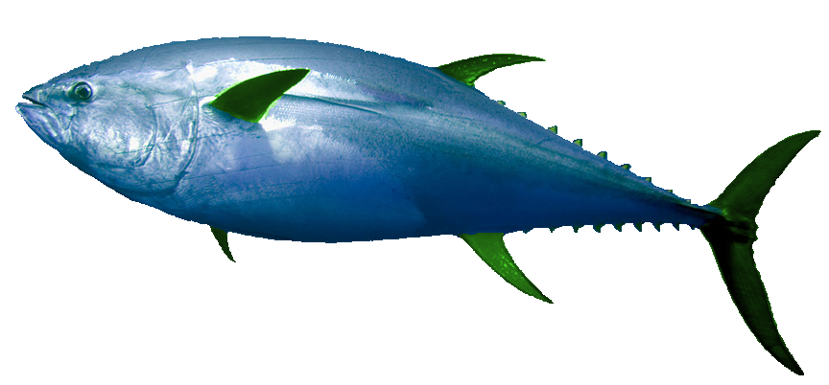
Imagine you’re a fish swimming through the topical ocean that our world represents. Topics all over the place! Swim towards one, look at it, swim around it, look at it from all perspectives, smell it, nibble at it - and go to the next if you don’t like it. Topics can be found in almost any place in that vast ocean so just keep your eyes open and find one! You will find one because remember – you’re the topical fish!

Lass das Themenfischchen schwimmen! Halte die Augen offen! und: Lies!!!

Topics of the International Weeks in 2010 – Some worked fine and some did not!

- To what extent was the development of air-craft engines accelerated by the “Supermarine S.6B”, victor in the Schneider-Cup?
- Chrysler Building – The Art Deco Skyscraper
- The Communist Party of Great Britain - Research question: Why was a communist party not formed before 1920?
- The Empire State Building - To what extant is the ES Building an example of a new architectural style?
- Prohibition - Why was the prohibition introduced in the USA?
- Black Friday - causes of the stock market crash
- To what extent did fashion express the changing role of women in the Roaring Twenties?
- The abdication of Edward VIII - What were the causes of his abdication and the consequences of his marriage?
- Organized crime during the Prohibition
- William Randolph Hearst - A friend of Hitler?
- Coca Cola’s Santa Claus
- National Industrial Recovery Act
- The Spanish Flu
- The New Woman - for example Amelia Earhart
- Art Deco in the USA – Which consequences did the international fair in Paris have on the USA?
- Al Capone - How did the autorities put Al Capone into jail?
- Aborigines Protection Amending Act 1915 - How did the APAA of 1915 change the life of the Aborigines
- Napier - The Art Deco City
- Rescue by integration: Ngata’s importance for Maori society
- Clara Bow- The It-Girl Was Clara Bow really an It-Girl?
- Vitamin D - Discovery and Development as the Cure for Rickets
- Lucky Luciano – a brutal gangster or a visionary?
- GANDHI AND THE BEGINNING OF CIVIL DISOBEDIENCE
- Gandhi´s Salt March – To what extent was Gandhi’s salt march succuessful?
- Nationality & Civil Rights of the Native Americans

